Haulage / Material Handling

## Water / Diesel Tanker Trailer

**Category:** Haulage & material handling

**Tag:** Tractor Mounted material handling implement

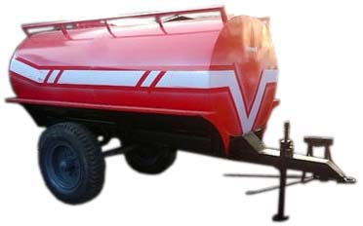 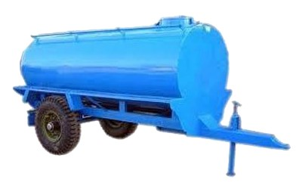

## Description

Water and Diesel tankers trailers are quite similar in appearance but have small differences in models. We have a comprehensive range of water / diesel tankers trailers in varied capacities from 400 gallons to 3000 gallons. These tankers trailers are specially designed & build up for the storage of water and diesel for irrigation, agriculture and as a fire extinguisher during fire hazards and for many other applications. It has an elliptical shape ensuring low centre of gravity and a sheet partition is provided for tanks stability against jerks created by water during transportation. Inside and outside channel support gives it more rigidity. It facilitates easy and bulk transportation of water and diesel quickly and simply as it gets easily mounted / detached with chassis body. It contains a ladder of angle section for easily mounting on top of platform and 2 manholes for ease of cleaning in both compartments.

|  |  |
| --- | --- |
| Specifications | |
| Capacity | 400 - 3000 gallons |
| Customize able | Yes |
| Material | Steel |
| Size / Dimension | Round |
| Axle | Single /Double |
| Tank sheet thickness | 4 - 6 MM |
| Chassis | 200 X 75 MM |
| Storage Material | Water / Diesel |
| Power Requirement: | 50 - 85 HP |
| No. of Wheels | 4 |

## Trolley / Trailer

**Category:** Haulage & material handling

**Tag:** Tractor Mounted material handling implement

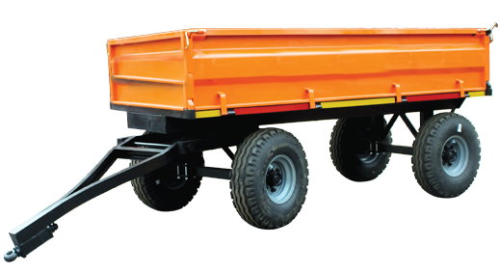 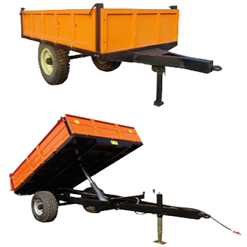

## Description

Trailers are being used widely all across the world. We offer both types of tractor mounted hydraulic jack & non hydraulic trailers. These trailers are specifically designed & build up to transport agricultural goods, agricultural residues and weeds from one field to another and for commercial purposes.

It is available in various sizes and load capacities from 3 tons to 20 tons, whereas we also manufacture according to the need of our client. It provides the flexibility of loading/ unloading which saves overall operating cost of transportation as it gets easily detached / mounted. It is well designed for towing and load stability. It is made of high quality steel, high grade hub, axle & bearings to enhance durability & reliability

|  |  |
| --- | --- |
| Specifications | |
| Capacity | 3 - 20 Tons |
| Customize able | Yes |
| Material | Steel |
| Size / Dimension | Rectangular |
| Axle | Single / Double |
| Chassis | 200 X 75 MM |
| Storage Material | Anything (solid) |
| Power Requirement: | 50 - 85 HP |
| No. of Wheels | 4 - 6 |